Nepal College of information Technology
Imadol lalitpur
Unit Test Spring Semester 2006

Program : BE Semester: Spring
Time : 2hrs Year : 2006
Full Marks: 60
Engineering Math-II
Attempt all questions

1. a) Solve 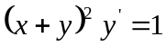 7
- Define integrating factor and solve
xdx + ydy + (x + y)² dy = 0 8

2. a) Solve xy' - 2y = x³e^{x} 7
b) State and prove existence theorem of Laplace Transform 8

Or
Solve the initial value problem using Laplace Transformation.
y" - 2y' -3y = 0 , y(0) = 1, y'(0) = 7.

3. i) a) Define unit-step function. Find Laplace transform of e^{-t} u₂ (t)
4
ii) Find f(t) if L [f (t) ] =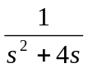
b) Find the Laplace transform of t² coswt. 7

4. a) Evaluate the integral by interchanging the order of integration:
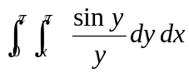 8
b) Integrate f(x,y) = 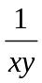 over the region :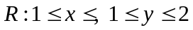 7

Nepal College of information Technology
Imadol lalitpur
Unit Test Spring Semester 2006

Program : BE Semester: Spring
Time : 2hrs Year : 2006
Full Marks: 60
Engineering Math-II
Attempt all questions

1. a) Solve 7
- Define integrating factor and solve
xdx + ydy + (x + y)² dy = 0 8

2. a) Solve xy' - 2y = x³e^{x} 7
b) State and prove existence theorem of Laplace Transform 8

Or
Solve the initial value problem using Laplace Transformation.
y" - 2y' -3y = 0 , y(0) = 1, y'(0) = 7.

3. i) a) Define unit-step function. Find Laplace transform of e^{-t} u₂ (t)
4
ii) Find f(t) if L [f (t) ] =
b) Find the Laplace transform of t² coswt. 7

4. a) Evaluate the integral by interchanging the order of integration:
8
b) Integrate f(x,y) = over the region : 7

